Activity Module 3 ▶ Project Schedule

project Schedule

Project Name: \_\_\_\_\_\_\_\_\_\_\_\_\_\_\_\_\_\_\_\_\_\_\_\_\_\_\_\_\_\_\_\_\_\_

Version: \_\_\_\_\_\_\_\_\_\_

Date: \_\_\_\_\_\_\_\_\_\_

TABLE OF CONTENTS

[1 Task Sequencing 3](#_Toc302418767)

[2 Work Package Estimation 7](#_Toc302418768)

[3 Schedule Creation 10](#_Toc302418769)

|  |
| --- |
| 1 Task Sequencing |

|  |
| --- |
| **Summary of Key Concepts** |
| **Task Sequencing**  Puts work packages in the correct sequence  **Two Rules**   * Define task relationships only between work packages, not summary tasks * Task relationships should reflect only sequence constraints, not resource constraints   **Two Display Methods**   * Predecessor Tables * Network Diagrams   **Notes**   * The task # is an index only and doesn’t reflect the order of tasks. * Milestones are anchors which have zero duration and do not affect the schedule |
| **C:\Dave\Personal\Individual\Social-Emotional\Pictures\2011\201102 - Miscellaneous\031.JPGMIP Case Study** |
| **WBS for 1) Strengthen Partnerships and 2) Provide Education** |

|  |
| --- |
| **Predecessor Table:**  **Network Diagram:** |

|  |
| --- |
| *C:\Dave\Personal\Individual\Social-Emotional\Pictures\2011\201102 - Miscellaneous\IMG_0132 (no logo).jpg***Select 5 to 7 work packages from your WBS and create a Predecessor Table and Network Diagram for your project.** |

|  |  |  |
| --- | --- | --- |
| **Predecessor Table** | | |
| **#** | **Task** | **Predecessor** |
| **1** |  |  |
| **2** |  |  |
| **3** |  |  |
| **4** |  |  |
| **5** |  |  |
| **6** |  |  |
| **7** |  |  |

|  |
| --- |
| **Network Diagram** |

|  |
| --- |
| 2 Work Package Estimation |

|  |
| --- |
| **Summary of Key Concepts** |
| **Work Package Estimation**  Detailed bottom-up estimation of time and resources for each work package.  **Labour estimates are the focus for this course. They require 3 inputs:**   * Labour hours – time required for 1 FTE to complete * Staffing in FTEs\* – # FTEs assigned to the work package * Wait time – necessary delay in completing work package   **Notes**   * FTE = Full-time equivalent. An FTE of 1.0 means that the person is equivalent to a full-time worker, while an FTE of 0.5 signals that the worker is only half-time * Active Time is an estimate of people’s time spent on the task * Wait Time is an estimate of the necessary delay to complete the task |
| **C:\Dave\Personal\Individual\Social-Emotional\Pictures\2011\201102 - Miscellaneous\031.JPGMIP Case Study** |
| **Assumptions:**   * 8-hour work day. All calculations rounded to the nearest day. * Project team members, clinic managers and volunteers will commit half a day to the project.   **Example of the estimation for Task 1:**   * 10 labour days is the estimate if one FTE was doing the job * This is divided by 2 resources who have agreed to work 0.5 FTE of time therefore 1 FTE total. 10 labour days / 1 FTE = 10 days of active working time * Next we estimate that there will be as much wait time as there is active time. Therefore 10 days wait time (waiting for contacted partners to get back to us, developing relationships, etc.) * Total task duration is then the active time of 10 days plus the wait time of 10 days = 20 days. |

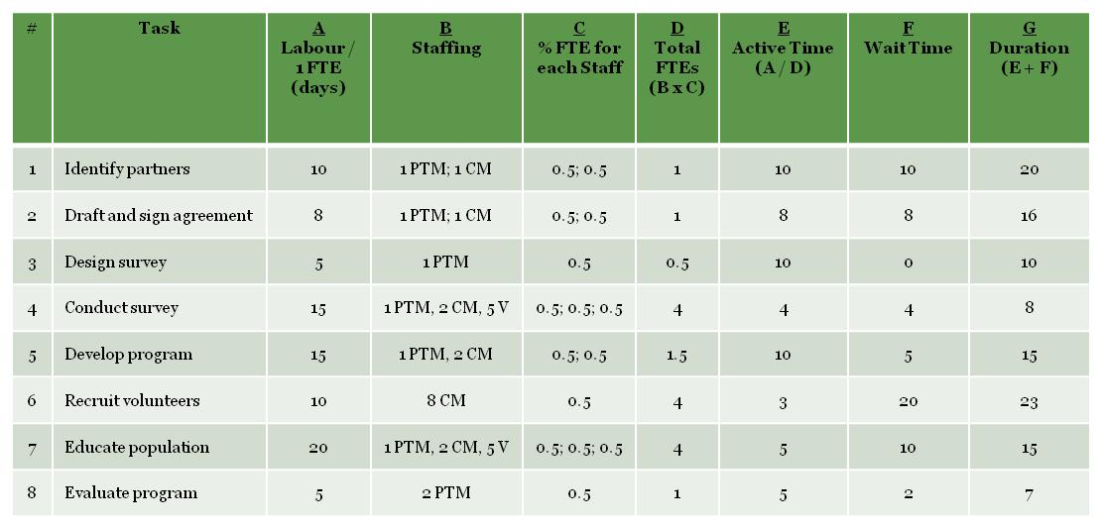

**Work Package Estimation:**

|  |
| --- |
| C:\Dave\Personal\Individual\Social-Emotional\Pictures\2011\201102 - Miscellaneous\IMG_0132 (no logo).jpg**Complete the Work Package Estimation for your project.** |

|  |  |  |  |  |  |  |  |  |
| --- | --- | --- | --- | --- | --- | --- | --- | --- |
| **G**  **Duration (E + F)** |  |  |  |  |  |  | Continue on back if needed | |
| **F**  **Wait Time** |  |  |  |  |  |  |  | |
| **E**  **Active Time (A / D)** |  |  |  |  |  |  |  | |
| **D**  **Total FTEs (B x C)** |  |  |  |  |  |  |  | |
| **C**  **% FTE for each Staff** |  |  |  |  |  |  |  | |
| **B**  **Staffing** |  |  |  |  |  |  |  | |
| **A**  **Labor / 1 FTE (days)** |  |  |  |  |  |  |  | |
| **Task** |  |  |  |  |  |  |  | |
| **#** | **1** | **2** | **3** | **4** | **5** | **6** | **7** | |
| 3 Schedule Creation | | | | | | | |

|  |
| --- |
| **Summary of Key Concepts** |
| **Schedule Creation**  A Gantt chart is used to display a project schedule in diagram form. The WBS is placed on the vertical axis and the task sequence and duration place on the horizontal axis. Two elements are required to create a Gantt Chart:   * Work Package Sequence * Work Package Duration |
| **C:\Dave\Personal\Individual\Social-Emotional\Pictures\2011\201102 - Miscellaneous\031.JPGMIP Case Study** |
|  |

|  |
| --- |
| C:\Dave\Personal\Individual\Social-Emotional\Pictures\2011\201102 - Miscellaneous\IMG_0132 (no logo).jpg**Complete the Gantt Chart below for your project using the correct dates.** |

