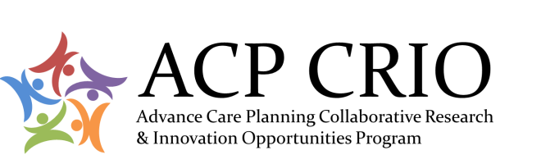

Medical-Legal Collaboration
Workshop Agenda

September 24, 2015, 1:15 to 3:45 pm
Red Deer Lodge

Adobeconnect link: tba
Dial-in Phone Numbers:
1-877-385-4099 Toll Free (Canada & USA)
403-232-0994 Calgary
780-421-1483 Edmonton
Access codes:
Moderator Access code: 4836867 #
Participant Access code: 3320113 #
- Agreement on Agenda

- Survey of Alberta Lawyers about Advance Care Planning

  - General Aims of Survey
  - Review of Draft Survey
    - Content – scope, clarity, response options
    - Burden
  - Distribution of Survey
  - Analysis and Dissemination of Results

- Next Steps for Collaboration

